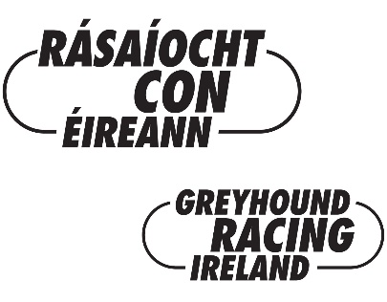

Special Authority Request Form

OWNER / TRAINERS DETAILS
Surname:
Forename(s):
Address:

Telephone Number:

ASSISTANTS DETAILS 1 |  | ASSISTANTS DETAILS 2 |  | ASSISTANTS DETAILS 3
Surname: |  | Surname: |  | Surname:
Forename(s): |  | Forename(s): |  | Forename(s):
Address: |  | Address: |  | Address:
Telephone Number |  | Telephone Number |  | Telephone Number

In making this application it is understood that I / we the above have read the Rules of Racing of the GBGB and amendments thereto published in the GBGB calendar and GBGB website and agree to abide by them. Greyhounds which have trialled or raced in UK under Special Authority will not be accepted for Trials or Racing in Ireland unless the ID cards for the greyhounds in question have been submitted to the Regulation Dept. of the GRI for authentication and the UK Trial/Race Formlines have been added to the GRI’s Race Management System.

GREYHOUND(S) AND EVENT
To train and manage the greyhound(s)

Whilst competing in the (name of race)

Date of the trial (s) | Date of the Round 1 | Date of Final

Stadium Name

Name of GBGB Licenced Trainer where greyhound can be inspected

Signature of Owner / Trainer requesting Authority _____________________________________________________
You must complete and sign this form and return it by emailing to joanne.obrien@grireland.ie or by post to the Regulation Department, Rásaíocht Con Éireann, Greenpark, Dock Road, Limerick V94 Y17X at least five working days prior to the race or trial in Great Britain.

